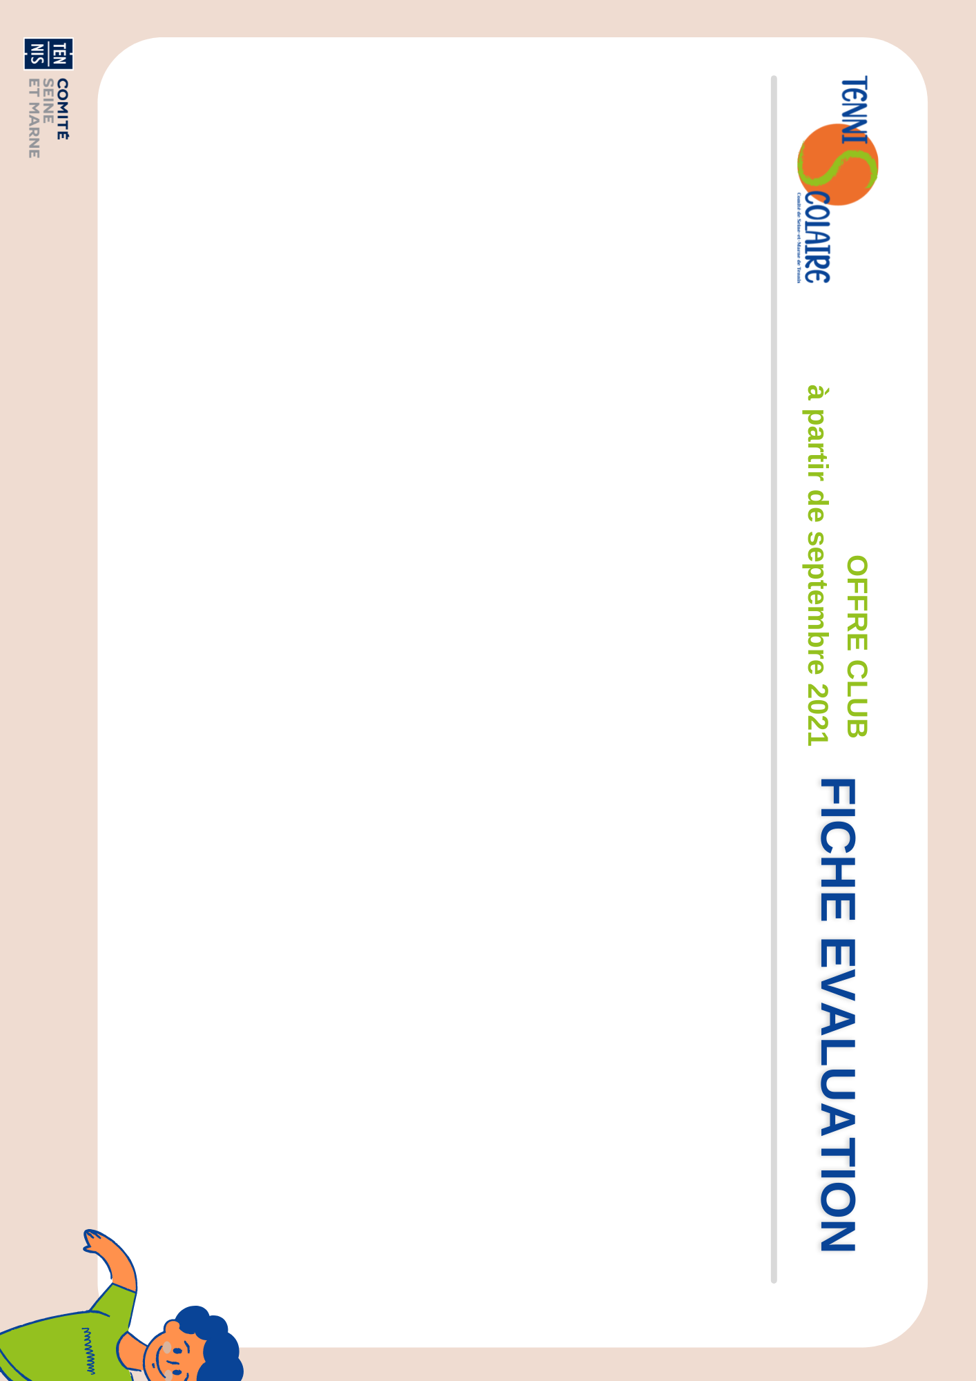

Nom du club :

Classe :

Nom de l’établissement :

|  |  |  |  |  |  |  |  |  |  |  |
| --- | --- | --- | --- | --- | --- | --- | --- | --- | --- | --- |
| Prénom | Envoyer la balle à la main à un endroit précis | Envoyer la balle avec la raquette | Renvoyer la balle avec la raquette | Renvoyer la balle en coup droit | Renvoyer la balle en revers | Faire un échange de 3 frappes | Faire un échange de 5 frappes | Faire un échange de 8 frappes | Lire la trajectoire de la balle | Envoyer la balle à un endroit précis |
|  |  |  |  |  |  |  |  |  |  |  |
|  |  |  |  |  |  |  |  |  |  |  |
|  |  |  |  |  |  |  |  |  |  |  |
|  |  |  |  |  |  |  |  |  |  |  |
|  |  |  |  |  |  |  |  |  |  |  |
|  |  |  |  |  |  |  |  |  |  |  |
|  |  |  |  |  |  |  |  |  |  |  |
|  |  |  |  |  |  |  |  |  |  |  |
|  |  |  |  |  |  |  |  |  |  |  |
|  |  |  |  |  |  |  |  |  |  |  |
|  |  |  |  |  |  |  |  |  |  |  |
|  |  |  |  |  |  |  |  |  |  |  |
|  |  |  |  |  |  |  |  |  |  |  |
|  |  |  |  |  |  |  |  |  |  |  |
|  |  |  |  |  |  |  |  |  |  |  |
|  |  |  |  |  |  |  |  |  |  |  |
|  |  |  |  |  |  |  |  |  |  |  |

|  |  |  |  |  |  |  |  |  |  |  |
| --- | --- | --- | --- | --- | --- | --- | --- | --- | --- | --- |
|  |  |  |  |  |  |  |  |  |  |  |
|  |  |  |  |  |  |  |  |  |  |  |
|  |  |  |  |  |  |  |  |  |  |  |
|  |  |  |  |  |  |  |  |  |  |  |
|  |  |  |  |  |  |  |  |  |  |  |
|  |  |  |  |  |  |  |  |  |  |  |
|  |  |  |  |  |  |  |  |  |  |  |
|  |  |  |  |  |  |  |  |  |  |  |
|  |  |  |  |  |  |  |  |  |  |  |
|  |  |  |  |  |  |  |  |  |  |  |
|  |  |  |  |  |  |  |  |  |  |  |
|  |  |  |  |  |  |  |  |  |  |  |
|  |  |  |  |  |  |  |  |  |  |  |
|  |  |  |  |  |  |  |  |  |  |  |
|  |  |  |  |  |  |  |  |  |  |  |
|  |  |  |  |  |  |  |  |  |  |  |
|  |  |  |  |  |  |  |  |  |  |  |



Bilan général :